Lab 5-1 Setting Up a User Filter
Goals | To set up a filter on an object to limit queries according to the user.
Scenario | ABC Company requires that sales representatives see only data in the regions for which they have an account. You will set up a Siebel Analytics filter to limit their queries.
Time | 10 – 15 minutes
Environment | 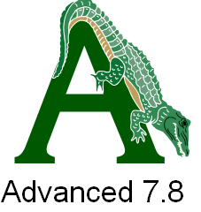
Instructions:
- Stop the Siebel Analytics Server service. To avoid login conflicts in testing your filter, you will edit the Analytics repository in offline mode.
- Open the ServArchAdv.rpd in offline mode.
  - Select Start > Programs > Siebel Analytics > Siebel Analytics Administration.
  - Select File > Open > Offline.
  - In the Open dialog box, navigate to C:\SiebelAnalytics\Repository and select ServArchAdv.rpd.
  - Click Open.
  - Verify that the user name is Administrator and the password is blank.
  - Click OK.
- Create a new user.
  - Select Manage > Security.
  - In the Security Manager window, select Users in the left pane.
  - In the right pane, right-click and select New User.
  - In the User dialog box, enter the following:
User Name | TALLEN
Full Name | Terry Allen
Password | TALLEN
Confirm Password | TALLEN
Logging Level | 2
  - Click OK.
  - Select Action > Close to close the Security Manager.
- Create an initialization block to populate the session variables used to limit the queries. In this case, you will use a row-wise initialization block to create a session variable named REGION_LIST which will contain a list of regions for which the user (the sales rep) has a customer (an account).
  - Select Manage > Variables.
  - In the Variable Manager window, select Action > New > Initialization Block.
  - In the Initialization Block dialog box, enter Query Filter in the Name field.
  - Select associate with session variables in the drop-down menu. This specifies that the variable created by the row-wise initialization block will be a session variable.
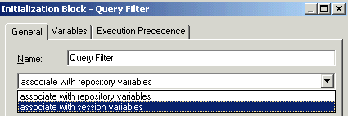
  - Select the Row-wise initialization check box.
  - Enter the following SQL into the Initialization string field. This will return a list of regions in the customer table associated with the user to a session variable named REGION_LIST.
SELECT DISTINCT 'REGION_LIST', Region FROM D1_customer2 WHERE Username = ':USER'
  - Click the Browse button for the Connection Pool.
  - In the Select Connection Pool dialog box, double-click SUPPLIER CP to select it.
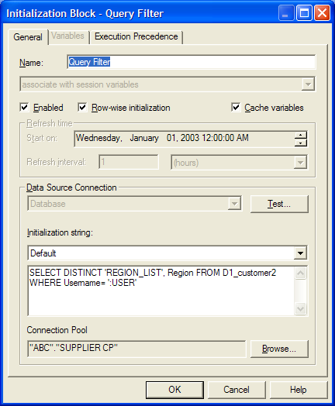
  - Click OK.
  - Close the Variable Manager by selecting Action > Close.
- Use the REGION_LIST session variable to filter queries against the customer table for Sales Representatives. In this case, you will create the filter for a specific user (TALLEN). More typically, you would create a Sales Reps user group, add TALLEN to that group, and set permissions for the group.
  - From the Administration Tool menu bar, choose Manage > Security.
  - Select Users from the Security tree on the left and double-click the user TALLEN in the right pane.
  - If necessary, click the User tab in the User dialog box.
  - Click Permissions.
  - In the User/Group Permissions dialog box, click the Filters tab and click Add.
  - In the Browse dialog box, expand the SupplierSales catalog in the left pane.
  - Select the Customers table and click the Select button.
  - In the User/Group Permissions dialog box, scroll to the right and click the ellipsis button to the right of the Business Model Filter field for the newly created filter to open the Expression Builder.
  - In the Expression Builder, enter the following expression. This expression filters customer records based on the multiple values in the REGION_LIST session variable.
SupplierSales.Customers.Region = VALUEOF(NQ_SESSION."REGION_LIST")
  - Click OK. Your filter should appear as follows:
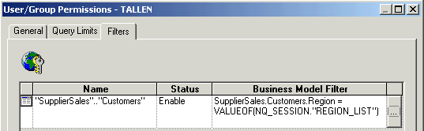
  - Click OK to close the User/Group Permissions dialog box.
  - Click OK to close the User dialog box.
  - Select Action > Close to close the Security Manager.
- Save the repository and check for global consistency.
- Close the Siebel Analytics Administration Tool and restart the Analytics Server service.
- Log in to the Analytics Web client and verify your configuration.
  - Log in to Analytics Web as TALLEN with password TALLEN. If an AutoComplete dialog box appears, select the Don’t offer to remember any more passwords check box and click No.
  - Using Windows Explorer, navigate to C:\SiebelAnalytics\Log and open NQQuery.log.
  - Scroll to the bottom and find the entry for the initialization block named 'Query Filter'.
  - How many records did the initialization block return?
  - Close NQQuery.log.
- Execute a query in Siebel Analytics to identify whether it is executing the query with a filter to limit the query.
  - In Siebel Analytics Web, click Answers.
  - Select the SupplierSales Subject Area.
  - Expand Customers and add Region to the Criteria.
  - Click the Results tab.
  - What Regions are displayed?
- Log out of Siebel Analytics Web and close the browser window.
Solutions 5-1 Setting Up a User Filter
Answers
8.d. How many records did the initialization block return?
2
9.e. What Regions are displayed?
Central and West

